# Airline Analysis Python SQL Project

Welcome to the Python SQL project! This project focuses on analyzing airline data stored in an SQLite database named travelers.sqlite. By leveraging Python libraries such as sqlite3, pandas, numpy, matplotlib, and seaborn, we aim to gain insights into various aspects of airline operations and revenue generation.



## 

## Objective

The objective of this project is to analyze the airline data to understand revenue generation, booking patterns, flight occupancy rates, and average ticket prices. By exploring these metrics, airlines can make informed decisions to optimize their operations, increase profitability, and enhance customer satisfaction

## Project Workflow

* Data Retrieval: The project begins by connecting to the SQLite database and retrieving tables present in the database.
* Data Exploration: Various tables such as aircrafts_data, airports_data, boarding_passes, bookings, flights, seats, ticket_flights, and tickets are queried to explore the dataset's structure and contents.
* Data Analysis and Visualization: The project involves performing data analysis and visualization to gain insights into different aspects of airline operations:
  + Analysis of ticket sales over time to understand booking trends.
  + Analysis of total revenue earned over time to track financial performance.
  + Calculation of class-wise average flight prices to understand pricing dynamics.
  + Calculation of occupancy rates to assess the utilization of available seats.
  + Exploration of factors impacting revenue generation and profitability.

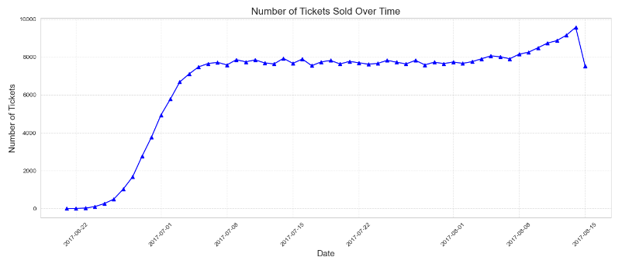

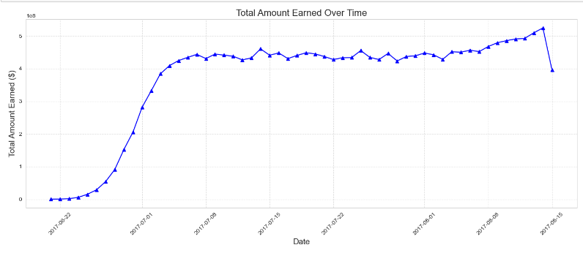

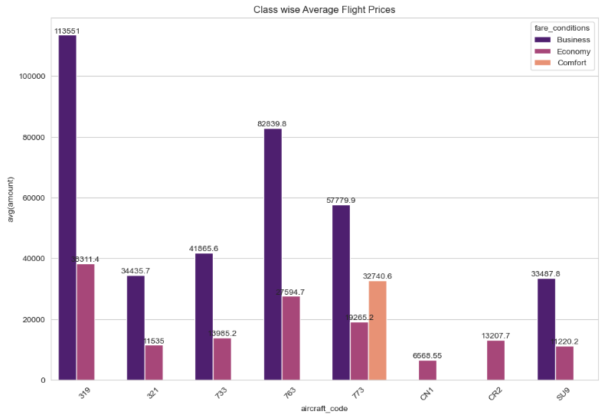

* Conclusion: The project concludes with insights drawn from the analysis, highlighting opportunities for airlines to optimize operations, enhance revenue, and improve customer satisfaction.

## Conclusion

In conclusion, this Python SQLite project provides valuable insights for airlines to optimize their operations and increase profitability. By analyzing revenue data, booking patterns, flight occupancy rates, and pricing dynamics, airlines can make informed decisions to maximize revenue while ensuring customer satisfaction and safety. Leveraging data-driven insights is essential for airlines to thrive in a competitive industry and achieve long-term success.

Happy analyzing and flying! ✈️📊